Защищено: Гапанюк Ю.Е.

" " 2022 г.

Демонстрация: Гапанюк Ю.Е.

" " 2022 г.

**Отчет по лабораторной работе № 2 по курсу Технологии машинного обучения**

**ГУИМЦ**

**Тема работы: " Обработка пропусков в данных, кодирование категориальных признаков, масштабирование данных. "**

13

(количество листов) Вариант № **3**

ИСПОЛНИТЕЛЬ:

студент группы ИУ5Ц-84Б

(подпись)

Семенова Анжелика

" " 2022 г.

Москва, МГТУ - 2022

# Цель лабораторной работы



Изучение способов предварительной обработки данных для дальнейшего формирования моделей.

# Задание

1. Выбрать набор данных (датасет), содержащий категориальные признаки и пропуски в данных. Для выполнения следующих пунктов можно использовать несколько различных наборов данных (один для обработки пропусков, другой для категориальных признаков и т.д.)
2. Для выбранного датасета (датасетов) на основе материалов лекции решить следующие задачи: обработку пропусков в данных;

кодирование категориальных признаков; масштабирование данных.

# Ход выполнения работы

## Текстовое описание набора данных

В качестве набора данных используется dataset рейтингов университетов мира на основании трёх рейтингов. Датасет доступен по адресу: <https://www.kaggle.com/mylesoneill/world-university-rankings>

Из набора данных будет рассматриваться только файл cwurData.csv .

Описание столбцов:

world_rank - мировой рейтинг университета

institution - название университета

country - страна, в которой расположен университет national_rank - рейтинг университета в стране его нахождения quality_of_education - рейтинг качества образования

quality_of_faculty - рейтинг качества профессорско-преподавательского состава

publications - рейтинг публикаций

infuence - рейтинг влияния

citations - количество студентов в университете

broad_impact - рейтинг за широкое влияние (предоставлен только за 2014 и 2015 гг. Остальное -

пропуски)

patents - рейтинг за патенты

score - общий балл, используемый для определения мирового рейтинга

year - год рейтинга (с 2012 по 2015 год)

## Основные характеристики набора данных

Подключаем все необходимые библиотеки

In [1]:

**import numpy as np import pandas as pd import seaborn as sns import matplotlib import matplotlib_inline**

**import matplotlib.pyplot as plt**



%matplotlib inline sns.set(style="ticks")

Подключаем Dataset

In [2]:

data = pd.read_csv('cwurData.csv', sep=",")

Размер набора данных

In [3]:

data.shape Out[3]:

(2200, 14)

Типы колонок

In [4]:

data.dtypes Out[4]:

world_rank int64

institution object

country object

national_rank int64 quality_of_education int64 alumni_employment int64

quality_of_faculty int64

publications int64

influence int64

citations int64

broad_impact float64 patents int64

score float64

year int64

dtype: object

Проверяем, есть ли пропущенные значения

|  |  |
| --- | --- |
| In [5]: |  |
| data.isnull().sum() |
| Out[5]: |
| world_rank | 0 |
| institution | 0 |
| country | 0 |
| national_rank | 0 |
| quality_of_education | 0 |
| alumni_employment | 0 |
| quality_of_faculty | 0 |
| publications | 0 |
| influence | 0 |
| citations | 0 |
| broad_impact | 200 |
| patents | 0 |
| score | 0 |
| year  dtype: int64 | 0 |
| Первые 5 строк датасета |  |

In [6]:



data.head()

Out[6]:

|  |  |  |  |  |  |  |  |  |
| --- | --- | --- | --- | --- | --- | --- | --- | --- |
|  | **world_rank** | **institution** | **country** | **national_rank** | **quality_of_education** | **alumni_employment** | **quality_of_faculty** | **publication** |
| **0** | 1 | Harvard University | USA | 1 | 7 | 9 | 1 |  |
| **1** | 2 | Massachusetts  Institute of Technology | USA | 2 | 9 | 17 | 3 | 1 |
| **2** | 3 | Stanford University | USA | 3 | 17 | 11 | 5 |  |
| **3** | 4 | University of Cambridge | United Kingdom | 1 | 10 | 24 | 4 | 1 |
| **4** | 5 | California Institute of | USA | 4 | 2 | 29 | 7 | 3 |
|  |  | Technology |  |  |  |  |  |  |
|  |  |  |  |  |  |  |  |  |
|  |  |  |  |  |  |  |  |  |
| In | [7]: |  |  |  |  |  |  |  |



total_count = data.shape[0]

print('Всего строк: **{}**'.format(total_count))

Всего строк: 2200

Процент пропусков в

broad_impact

|  |  |  |
| --- | --- | --- |
|  |  |  |

In [8]:



(200 / 2200) * 100

Out[8]:

9.090909090909092

Настройка отображения графиков

In [9]:



*# Задание формата графиков для сохранения высокого качества PNG* **from IPython.display import** set_matplotlib_formats matplotlib_inline.backend_inline.set_matplotlib_formats("retina") *# Задание ширины графиков, чтобы они помещались на A4*

## Обработка пропусков данных

### Очистка строк

Можно очистить строки, содержащие пропуски. При этом останутся данные только за 2014 и 2015 гг (см.

описание датасета)

In [10]:



*# Удаление строк, содержащих пустые значения* data_no_null = data.dropna(axis=0, how='any') (data.shape, data_no_null.shape)

Out[10]:

((2200, 14), (2000, 14))

Выведем первые 11 строк, чтобы убедиться, что данные в предпросмотре CSV показывает не совсем верно)

national_rank

In [11]:



data_no_null.head(11)

Out[11]:

|  |  |  |  |  |  |  |  |  |
| --- | --- | --- | --- | --- | --- | --- | --- | --- |
|  | **world_rank** | **institution** | **country** | **national_rank** | **quality_of_education** | **alumni_employment** | **quality_of_faculty** | **publicati**o |
| **200** | 1 | Harvard University | USA | 1 | 1 | 1 | 1 |  |
| **201** | 2 | Stanford University | USA | 2 | 11 | 2 | 4 |  |
| **202** | 3 | Massachusetts  Institute of Technology | USA | 3 | 3 | 11 | 2 |  |
| **203** | 4 | University of Cambridge | United Kingdom | 1 | 2 | 10 | 5 |  |
| **204** | 5 | University of  Oxford | United Kingdom | 2 | 7 | 12 | 10 |  |
| **205** | 6 | Columbia University | USA | 4 | 13 | 8 | 9 |  |
| **206** | 7 | University of California, Berkeley | USA | 5 | 4 | 22 | 6 |  |
| **207** | 8 | University of  Chicago | USA | 6 | 10 | 14 | 8 |  |
| **208** | 9 | Princeton University | USA | 7 | 5 | 16 | 3 |  |
| **209** | 10 | Yale University | USA | 8 | 9 | 25 | 11 |  |
| **210** | 11 | Cornell University | USA | 9 | 12 | 18 | 19 |  |

In [12]:



total_count = data_no_null.shape[0] print('Всего строк: **{}**'.format(total_count))

|  |  |  |
| --- | --- | --- |
|  |  |  |

Всего строк: 2000

### Внедрение значений

In [13]:

числовые (Jupyter Lab в







*Фильтр по колонкам с пропущенными значениями*



*# Выберем числовые колонки с пропущенными значениями # Цикл по колонкам датасета*

num_cols = []

**for** col **in** data.columns:

*# Количество пустых значений*

temp_null_count = data[data[col].isnull()].shape[0] dt = str(data[col].dtype)

**if** temp_null_count>0 **and** (dt=='float64' **or** dt=='int64'): num_cols.append(col)

temp_perc = round((temp_null_count / total_count) * 100.0, 2)

print('Колонка **{}**. Тип данных **{}**. Количество пустых значений **{}**, **{}**%.'.format(col

, dt, temp_null_count, temp_perc))

Колонка broad_impact. Тип данных float64. Количество пустых значений 200, 10.0%. In [33]:





data_num = data[num_cols] data_num

Out[33]:

**broad_impact**

**0** NaN

**1** NaN

**2** NaN

**3** NaN

**4** NaN

**...** ...

**2195** 969.0

**2196** 981.0

**2197** 975.0

**2198** 975.0

**2199** 981.0

2200 rows × 1 columns

In [34]:

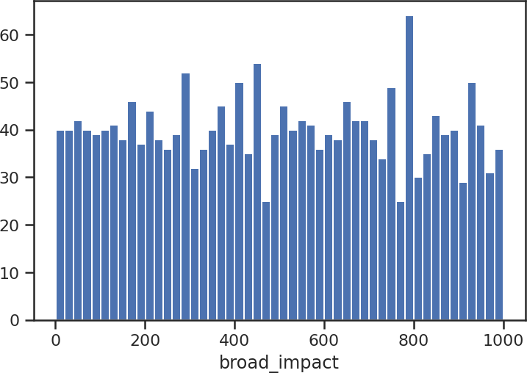



*# Гистограмма по признакам*

**for** col **in** data_num: plt.hist(data[col], 50) plt.xlabel(col) plt.show()

[Будем использовать встроенные средства импьютации библиотеки scikit-learn - https://scikit](https://scikit-learn.org/stable/modules/impute.html)- [learn.org/stable/modules/impute.html](https://scikit-learn.org/stable/modules/impute.html)

In [35]:



data_num_MasVnrArea = data_num[['broad_impact']] data_num_MasVnrArea.head()

Out[35]:

**broad_impact**

**0** NaN

**1** NaN

**2** NaN

**3** NaN



**4** NaN

**broad_impact**

In [36]:



**from sklearn.impute import** SimpleImputer **from sklearn.impute import** MissingIndicator

In [37]:



*# Фильтр для проверки заполнения пустых значений*

indicator = MissingIndicator()

mask_missing_values_only = indicator.fit_transform(data_num_MasVnrArea) mask_missing_values_only

Out[37]:

array([[ True],

[ True],

[ True],

...,

[False],

[False],

[False]])

С помощью класса [SimpleImpute](https://scikit-learn.org/stable/modules/generated/sklearn.impute.SimpleImputer.html#sklearn.impute.SimpleImputer)r проверим импьютацию различными [показателями центра распределения](https://ru.wikipedia.org/wiki/%D0%9F%D0%BE%D0%BA%D0%B0%D0%B7%D0%B0%D1%82%D0%B5%D0%BB%D0%B8_%D1%86%D0%B5%D0%BD%D1%82%D1%80%D0%B0_%D1%80%D0%B0%D1%81%D0%BF%D1%80%D0%B5%D0%B4%D0%B5%D0%BB%D0%B5%D0%BD%D0%B8%D1%8F)

In [38]:



strategies=['mean', 'median', 'most_frequent']

In [39]:



**def** test_num_impute(strategy_param):

imp_num = SimpleImputer(strategy=strategy_param) data_num_imp = imp_num.fit_transform(data_num_MasVnrArea) **return** data_num_imp[mask_missing_values_only]

In [40]:



strategies[0], test_num_impute(strategies[0])

Out[40]:

('mean',

|  |  |  |  |  |  |
| --- | --- | --- | --- | --- | --- |
| array([496.6995, | 496.6995, | 496.6995, | 496.6995, | 496.6995, | 496.6995, |
| 496.6995, | 496.6995, | 496.6995, | 496.6995, | 496.6995, | 496.6995, |
| 496.6995, | 496.6995, | 496.6995, | 496.6995, | 496.6995, | 496.6995, |
| 496.6995, | 496.6995, | 496.6995, | 496.6995, | 496.6995, | 496.6995, |
| 496.6995, | 496.6995, | 496.6995, | 496.6995, | 496.6995, | 496.6995, |
| 496.6995, | 496.6995, | 496.6995, | 496.6995, | 496.6995, | 496.6995, |
| 496.6995, | 496.6995, | 496.6995, | 496.6995, | 496.6995, | 496.6995, |
| 496.6995, | 496.6995, | 496.6995, | 496.6995, | 496.6995, | 496.6995, |
| 496.6995, | 496.6995, | 496.6995, | 496.6995, | 496.6995, | 496.6995, |
| 496.6995, | 496.6995, | 496.6995, | 496.6995, | 496.6995, | 496.6995, |
| 496.6995, | 496.6995, | 496.6995, | 496.6995, | 496.6995, | 496.6995, |
| 496.6995, | 496.6995, | 496.6995, | 496.6995, | 496.6995, | 496.6995, |
| 496.6995, | 496.6995, | 496.6995, | 496.6995, | 496.6995, | 496.6995, |
| 496.6995, | 496.6995, | 496.6995, | 496.6995, | 496.6995, | 496.6995, |
| 496.6995, | 496.6995, | 496.6995, | 496.6995, | 496.6995, | 496.6995, |
| 496.6995, | 496.6995, | 496.6995, | 496.6995, | 496.6995, | 496.6995, |
| 496.6995, | 496.6995, | 496.6995, | 496.6995, | 496.6995, | 496.6995, |
| 496.6995, | 496.6995, | 496.6995, | 496.6995, | 496.6995, | 496.6995, |
| 496.6995, | 496.6995, | 496.6995, | 496.6995, | 496.6995, | 496.6995, |
| 496.6995, | 496.6995, | 496.6995, | 496.6995, | 496.6995, | 496.6995, |
| 496.6995, | 496.6995, | 496.6995, | 496.6995, | 496.6995, | 496.6995, |
| 496.6995, | 496.6995, | 496.6995, | 496.6995, | 496.6995, | 496.6995, |
| 496.6995, | 496.6995, | 496.6995, | 496.6995, | 496.6995, | 496.6995, |
| 496.6995, | 496.6995, | 496.6995, | 496.6995, | 496.6995, | 496.6995, |
| 496.6995, | 496.6995, | 496.6995, | 496.6995, | 496.6995, | 496.6995, |
| 496.6995, | 496.6995, | 496.6995, | 496.6995, | 496.6995, | 496.6995, |
| 496.6995, | 496.6995, | 496.6995, | 496.6995, | 496.6995, | 496.6995, |
| 496.6995, | 496.6995, | 496.6995, | 496.6995, | 496.6995, | 496.6995, |

496.6995, 496.6995, 496.6995, 496.6995, 496.6995, 496.6995,

496.6995, 496.6995, 496.6995, 496.6995, 496.6995, 496.6995,

496.6995, 496.6995, 496.6995, 496.6995, 496.6995, 496.6995,

496.6995, 496.6995, 496.6995, 496.6995, 496.6995, 496.6995,

496.6995, 496.6995, 496.6995, 496.6995, 496.6995, 496.6995,

496.6995, 496.6995]))

In [41]:



strategies[1], test_num_impute(strategies[1])

Out[41]:

('median',

|  |  |  |  |  |  |  |  |  |  |  |
| --- | --- | --- | --- | --- | --- | --- | --- | --- | --- | --- |
| array([496., | 496., | 496., | 496., | 496., | 496., | 496., | 496., | 496., | 496., | 496., |
| 496., | 496., | 496., | 496., | 496., | 496., | 496., | 496., | 496., | 496., | 496., |
| 496., | 496., | 496., | 496., | 496., | 496., | 496., | 496., | 496., | 496., | 496., |
| 496., | 496., | 496., | 496., | 496., | 496., | 496., | 496., | 496., | 496., | 496., |
| 496., | 496., | 496., | 496., | 496., | 496., | 496., | 496., | 496., | 496., | 496., |
| 496., | 496., | 496., | 496., | 496., | 496., | 496., | 496., | 496., | 496., | 496., |
| 496., | 496., | 496., | 496., | 496., | 496., | 496., | 496., | 496., | 496., | 496., |
| 496., | 496., | 496., | 496., | 496., | 496., | 496., | 496., | 496., | 496., | 496., |
| 496., | 496., | 496., | 496., | 496., | 496., | 496., | 496., | 496., | 496., | 496., |
| 496., | 496., | 496., | 496., | 496., | 496., | 496., | 496., | 496., | 496., | 496., |
| 496., | 496., | 496., | 496., | 496., | 496., | 496., | 496., | 496., | 496., | 496., |
| 496., | 496., | 496., | 496., | 496., | 496., | 496., | 496., | 496., | 496., | 496., |
| 496., | 496., | 496., | 496., | 496., | 496., | 496., | 496., | 496., | 496., | 496., |
| 496., | 496., | 496., | 496., | 496., | 496., | 496., | 496., | 496., | 496., | 496., |
| 496., | 496., | 496., | 496., | 496., | 496., | 496., | 496., | 496., | 496., | 496., |
| 496., | 496., | 496., | 496., | 496., | 496., | 496., | 496., | 496., | 496., | 496., |
| 496., | 496., | 496., | 496., | 496., | 496., | 496., | 496., | 496., | 496., | 496., |
| 496., | 496., | 496., | 496., | 496., | 496., | 496., | 496., | 496., | 496., | 496., |

496., 496.]))

In [42]:



strategies[2], test_num_impute(strategies[2])

Out[42]:

('most_frequent',

|  |  |  |  |  |  |  |  |  |  |  |
| --- | --- | --- | --- | --- | --- | --- | --- | --- | --- | --- |
| array([642., | 642., | 642., | 642., | 642., | 642., | 642., | 642., | 642., | 642., | 642., |
| 642., | 642., | 642., | 642., | 642., | 642., | 642., | 642., | 642., | 642., | 642., |
| 642., | 642., | 642., | 642., | 642., | 642., | 642., | 642., | 642., | 642., | 642., |
| 642., | 642., | 642., | 642., | 642., | 642., | 642., | 642., | 642., | 642., | 642., |
| 642., | 642., | 642., | 642., | 642., | 642., | 642., | 642., | 642., | 642., | 642., |
| 642., | 642., | 642., | 642., | 642., | 642., | 642., | 642., | 642., | 642., | 642., |
| 642., | 642., | 642., | 642., | 642., | 642., | 642., | 642., | 642., | 642., | 642., |
| 642., | 642., | 642., | 642., | 642., | 642., | 642., | 642., | 642., | 642., | 642., |
| 642., | 642., | 642., | 642., | 642., | 642., | 642., | 642., | 642., | 642., | 642., |
| 642., | 642., | 642., | 642., | 642., | 642., | 642., | 642., | 642., | 642., | 642., |
| 642., | 642., | 642., | 642., | 642., | 642., | 642., | 642., | 642., | 642., | 642., |
| 642., | 642., | 642., | 642., | 642., | 642., | 642., | 642., | 642., | 642., | 642., |
| 642., | 642., | 642., | 642., | 642., | 642., | 642., | 642., | 642., | 642., | 642., |
| 642., | 642., | 642., | 642., | 642., | 642., | 642., | 642., | 642., | 642., | 642., |
| 642., | 642., | 642., | 642., | 642., | 642., | 642., | 642., | 642., | 642., | 642., |
| 642., | 642., | 642., | 642., | 642., | 642., | 642., | 642., | 642., | 642., | 642., |
| 642., | 642., | 642., | 642., | 642., | 642., | 642., | 642., | 642., | 642., | 642., |
| 642., | 642., | 642., | 642., | 642., | 642., | 642., | 642., | 642., | 642., | 642., |

642., 642.]))

In [43]:



*# Более сложная функция, которая позволяет задавать колонку и вид импьютации*

**def** test_num_impute_col(dataset, column, strategy_param): temp_data = dataset[[column]]

indicator = MissingIndicator()

mask_missing_values_only = indicator.fit_transform(temp_data)

imp_num = SimpleImputer(strategy=strategy_param) data_num_imp = imp_num.fit_transform(temp_data)





filled_data = data_num_imp[mask_missing_values_only]

**return** column, strategy_param, filled_data.size, filled_data[0], filled_data[filled_d ata.size-1]

In [44]:



data[['broad_impact']].describe()

Out[44]:

|  |  |
| --- | --- |
|  | **broad_impact** |
| **count** | 2000.000000 |
| **mean** | 496.699500 |
| **std** | 286.919755 |
| **min** | 1.000000 |
| **25%** | 250.500000 |
| **50%** | 496.000000 |
| **75%** | 741.000000 |
| **max** | 1000.000000 |

In [47]:



test_num_impute_col(data, 'broad_impact', strategies[0])

Out[47]:

('broad_impact', 'mean', 200, 496.6995, 496.6995)

In [48]:



test_num_impute_col(data, 'broad_impact', strategies[1])

Out[48]:

('broad_impact', 'median', 200, 496.0, 496.0)

In [50]:



test_num_impute_col(data, 'broad_impact', strategies[2])

Out[50]:

('broad_impact', 'most_frequent', 200, 642.0, 642.0)

## Кодирование категориальных признаков

Преобразуем названия стран, городов, ... в числовые зеачения (label encoding)

In [14]:



**from sklearn.preprocessing import** LabelEncoder, OneHotEncoder

======> <==========

institution

In [15]:



le = LabelEncoder()

institution_le = le.fit_transform(data_no_null['institution'])

In [16]:



data_no_null['institution'].unique()

Out[16]:

array(['Harvard University', 'Stanford University', 'Massachusetts Institute of Technology', ...,

'Babeș-Bolyai University', 'Henan Normal University', 'Southwest Jiaotong University'], dtype=object)

In [17]:



arr_institution_encoded = np.unique(institution_le) arr_institution_encoded

Out[17]:

array([ 0, 1, 2, ..., 1020, 1021, 1022])

In [18]:



le.inverse_transform([n **for** n **in** range(1023)])

Out[18]:

array(['AGH University of Science and Technology', 'Aalborg University', 'Aalto University', ..., 'École normale supérieure de Cachan', 'École normale supérieure de Lyon', 'Örebro University'],

dtype=object)

======> <==========

country

In [19]:



le_country = LabelEncoder()

country_le = le_country.fit_transform(data_no_null['country'])

In [20]:



data_no_null['country'].unique()

Out[20]:

array(['USA', 'United Kingdom', 'Japan', 'Switzerland', 'Israel', 'South Korea', 'Canada', 'France', 'Russia', 'China', 'Taiwan', 'Sweden', 'Singapore', 'Denmark', 'Germany', 'Netherlands', 'Italy', 'Belgium', 'Australia', 'Finland', 'Norway',

'South Africa', 'Spain', 'Brazil', 'Hong Kong', 'Ireland', 'Austria', 'New Zealand', 'Portugal', 'Thailand', 'Czech Republic', 'Malaysia', 'India', 'Greece', 'Mexico', 'Hungary', 'Argentina', 'Turkey', 'Poland', 'Saudi Arabia', 'Chile', 'Iceland', 'Slovenia', 'Estonia', 'Lebanon', 'Croatia', 'Colombia', 'Slovak Republic', 'Iran', 'Egypt', 'Serbia', 'Bulgaria', 'Lithuania', 'Uganda', 'United Arab Emirates', 'Uruguay', 'Cyprus', 'Romania',

|  |  |
| --- | --- |
| 'Puerto Rico'], | dtype=object) |
| In [21]: |  |
| np.unique(country_le) |  |
| Out[21]: |  |
| array([ 0, 1, 2, 3, | 4, 5, 6, 7, 8, 9, 10, 11, 12, 13, 14, 15, 16, |
| 17, 18, 19, 20, | 21, 22, 23, 24, 25, 26, 27, 28, 29, 30, 31, 32, 33, |
| 34, 35, 36, 37, | 38, 39, 40, 41, 42, 43, 44, 45, 46, 47, 48, 49, 50, |
| 51, 52, 53, 54, | 55, 56, 57, 58]) |

In [22]:



le_country.inverse_transform([n **for** n **in** range(59)])

Out[22]:

array(['Argentina', 'Australia', 'Austria', 'Belgium', 'Brazil', 'Bulgaria', 'Canada', 'Chile', 'China', 'Colombia', 'Croatia', 'Cyprus', 'Czech Republic', 'Denmark', 'Egypt', 'Estonia', 'Finland', 'France', 'Germany', 'Greece', 'Hong Kong', 'Hungary',

'Iceland', 'India', 'Iran', 'Ireland', 'Israel', 'Italy', 'Japan', 'Lebanon', 'Lithuania', 'Malaysia', 'Mexico', 'Netherlands',



data_digit.dtypes

'New Zealand', 'Norway', 'Poland', 'Portugal', 'Puerto Rico', 'Romania', 'Russia', 'Saudi Arabia', 'Serbia', 'Singapore', 'Slovak Republic', 'Slovenia', 'South Africa', 'South Korea', 'Spain', 'Sweden', 'Switzerland', 'Taiwan', 'Thailand', 'Turkey', 'USA', 'Uganda', 'United Arab Emirates', 'United Kingdom', 'Uruguay'], dtype=object)

In [23]:



data_no_null.head()

Out[23]:

|  |  |  |  |  |  |  |  |  |
| --- | --- | --- | --- | --- | --- | --- | --- | --- |
|  | **world_rank** | **institution** | **country** | **national_rank** | **quality_of_education** | **alumni_employment** | **quality_of_faculty** | **publicati**o |
| **200** | 1 | Harvard University | USA | 1 | 1 | 1 | 1 |  |
| **201** | 2 | Stanford University | USA | 2 | 11 | 2 | 4 |  |
| **202** | 3 | Massachusetts  Institute of Technology | USA | 3 | 3 | 11 | 2 |  |
| **203** | 4 | University of Cambridge | United Kingdom | 1 | 2 | 10 | 5 |  |
| **204** | 5 | University of  Oxford | United Kingdom | 2 | 7 | 12 | 10 |  |

|  |  |  |
| --- | --- | --- |
|  |  |  |

In [24]:



data_digit = data_no_null.copy() *#data_digit.pop('institution') #data_digit.pop('country')* data_digit["institution"] = institution_le data_digit['country'] = country_le data_digit

Out[24]:

|  |  |  |  |  |  |  |  |  |  |
| --- | --- | --- | --- | --- | --- | --- | --- | --- | --- |
|  | **world_rank** | **institution** | **country** | **national_rank** | **quality_of_education** | **alumni_employment** | **quality_of_faculty** | **publications** | **i** |
| **200** | 1 | 184 | 54 | 1 | 1 | 1 | 1 | 1 |  |
| **201** | 2 | 511 | 54 | 2 | 11 | 2 | 4 | 5 |  |
| **202** | 3 | 312 | 54 | 3 | 3 | 11 | 2 | 15 |  |
| **203** | 4 | 637 | 57 | 1 | 2 | 10 | 5 | 10 |  |
| **204** | 5 | 819 | 57 | 2 | 7 | 12 | 10 | 11 |  |
| **...** | ... | ... | ... | ... | ... | ... | ... | ... |  |
| **2195** | 996 | 954 | 37 | 7 | 367 | 567 | 218 | 926 |  |
| **2196** | 997 | 11 | 14 | 4 | 236 | 566 | 218 | 997 |  |
| **2197** | 998 | 132 | 4 | 18 | 367 | 549 | 218 | 830 |  |
| **2198** | 999 | 576 | 48 | 40 | 367 | 567 | 218 | 886 |  |
| **2199** | 1000 | 74 | 8 | 83 | 367 | 567 | 218 | 861 |  |

2000 rows × 14 columns

|  |  |  |
| --- | --- | --- |
|  |  |  |

Проверяем типы данных

In [25]:



|  |  |
| --- | --- |
| Out[25]: |  |
| world_rank | int64 |
| institution | int64 |
| country | int64 |
| national_rank | int64 |
| quality_of_education | int64 |
| alumni_employment | int64 |
| quality_of_faculty | int64 |
| publications | int64 |
| influence | int64 |
| citations | int64 |
| broad_impact | float64 |
| patents | int64 |
| score | float64 |
| year | int64 |
| dtype: object |  |

## Масштабирование данных

Масштабирование пудем проводить на (где нет категориальных признаков)

data_digit

In [26]:



**from sklearn.preprocessing import** MinMaxScaler, StandardScaler, Normalizer

### MinMax масштабирование

=====> <=====

world_rank

In [27]:



sc1 = MinMaxScaler()

sc1_data = sc1.fit_transform(data_digit[['broad_impact']])

In [28]:

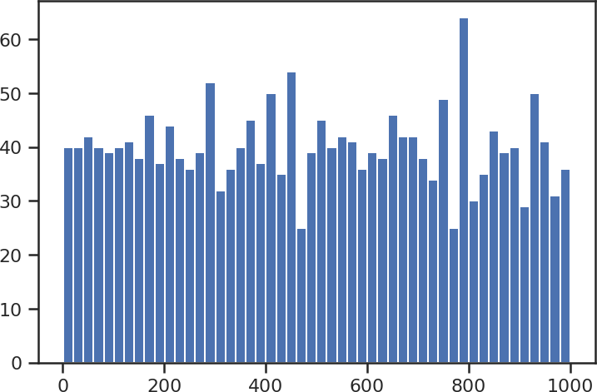



plt.hist(data_digit['broad_impact'], 50) plt.show()

In [29]:

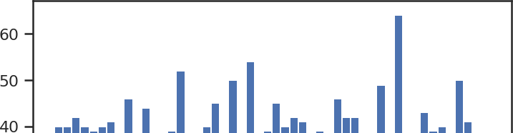



plt.hist(sc1_data, 50) plt.show()

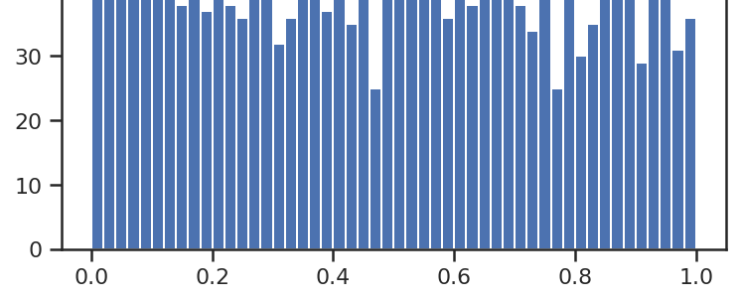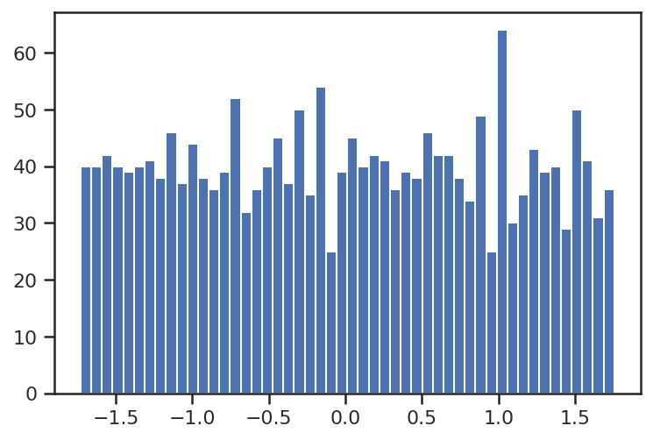

In [ ]:

### Масштабирование данных на основе Z-оценки - StandardScaler

In [30]:

sc2 = StandardScaler()

sc2_data = sc2.fit_transform(data_digit[['broad_impact']])

In [31]:

plt.hist(sc2_data, 50) plt.show()

In [ ]: